TABLE 1

Outline of the complete degree programme

- Year 1

Number of hours of study corresponding to 1 ECTS credit:

Module/course unit title | Credits (ECTS) | Compulsory (C), Semi-optional (S) or Elective (E) | Total Teaching Hours |  |  |  | Pre-requisites
 |  |  | Lecture | Practical | Other

Nature and Extent of other Learning Activities, e.g. guided study, team exercises:

- Year 2

Module/course unit title | Credits (ECTS) | Compulsory (C), Semi-optional (S) or Elective (E) | Total Teaching Hours |  |  |  | Pre-requisites
 |  |  | Lecture | Practical | Other

Nature and Extent of other Learning Activities, e.g. guided study, team exercises:

- Year 3

Module/course unit title | Credits (ECTS) | Compulsory (C), Semi-optional (S) or Elective (E) | Total Teaching Hours |  |  |  | Pre-requisites
 |  |  | Lecture | Practical | Other

Nature and Extent of other Learning Activities, e.g. guided study, team exercises:

TABLE 2

Learning Outcomes: Subject Knowledge

Aspect of chemistry | Treated in  module / course unit
- Major aspects of chemical terminology, nomenclature, conventions and units
- The major types of chemical reaction and the main characteristics associated with them
- The principles and procedures used in chemical analysis and the characterisation of chemical compounds
- The principal techniques of structural investigations, including spectroscopy
- The characteristics of the different states of matter and the theories used to describe them.
- The principles of thermodynamics and their applications to chemistry
- The principles of quantum mechanics and their application to the description of the structure and properties of atoms and molecules
- The kinetics of chemical change, including catalysis; the mechanistic interpretation of chemical reactions
- The characteristic properties of elements and their compounds, including group relationships and trends within the Periodic Table
- The structural features of chemical elements and their compounds, including stereochemistry
- The properties of aliphatic, aromatic, heterocyclic and organometallic compounds
- The nature and behaviour of functional groups in organic molecules
- Major synthetic pathways in organic chemistry, involving functional group interconversions and carbon-carbon and carbon-heteroatom bond formation
- The relation between bulk properties and the properties of individual atoms and molecules, including macromolecules (both natural and man-made), polymers and other related materials

The structure and reactivity of important classes of biomolecules and the chemistry of important biological processes

Statement of Applicant

As stated in the Eurobachelor® paper:

" A primary aim of the Eurobachelor® qualification is to provide a degree which will be recognised by other European institutions as being of a standard which will provide automatic right of access (though not right of admission, which is the prerogative of the receiving institution) to chemistry Master programmes."

The Self-Evaluation Report must therefore end with the following declaration:

I (full name, position as head of the institution/department/faculty responsible for the study programme) hereby agree that this (institution/department/faculty) will, if awarded the Eurobachelor® label, recognise Bachelor degrees in chemistry awarded by other institutions holding the Eurobachelor® label as providing automatic right of access (but not of admission) to chemistry Master programmes offered by this (institution / department / faculty).

I hereby agree that this (institution/department/faculty) will, if awarded the Eurobachelor® label, display the official Eurobachelor® logo on the website of this (institution / department / faculty) and remove this label from the website as soon as the validity term of the awarded Eurobachelor® label expired.

I hereby authorise ECTN to archive the information provided as well as to use it (without giving the source) to further scientific, statistical, publicity, and educational use.

I agree that the Self-Evaluation Report together with the Site Visit Report will be published on the ECTN website in case the label is awarded.

It must also be signed, stamped and dated by the person making the declaration.

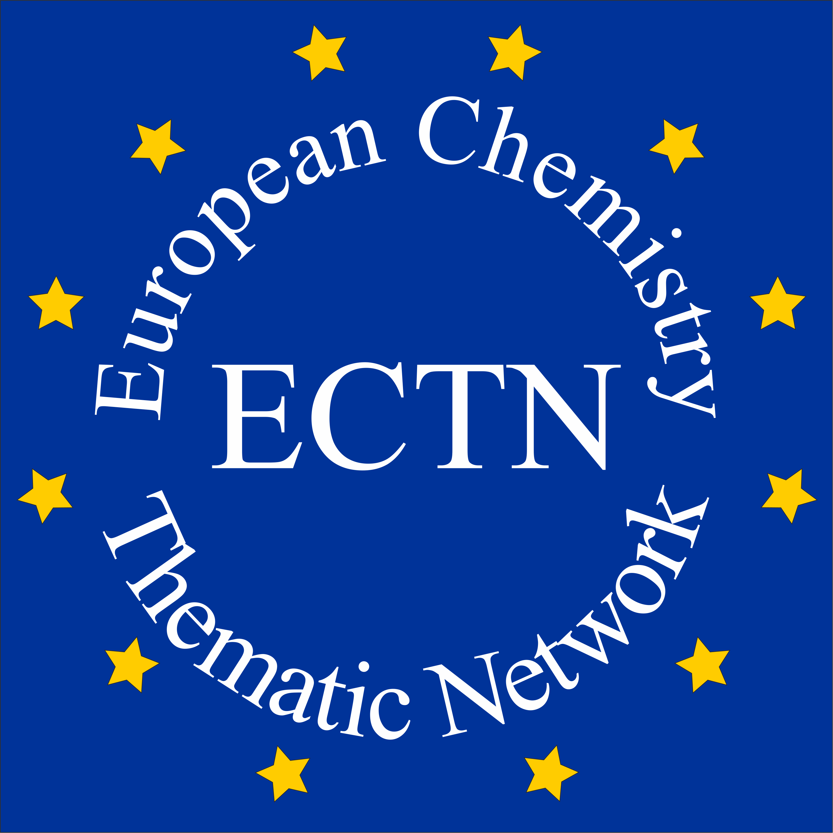 | Student Mobility Database | 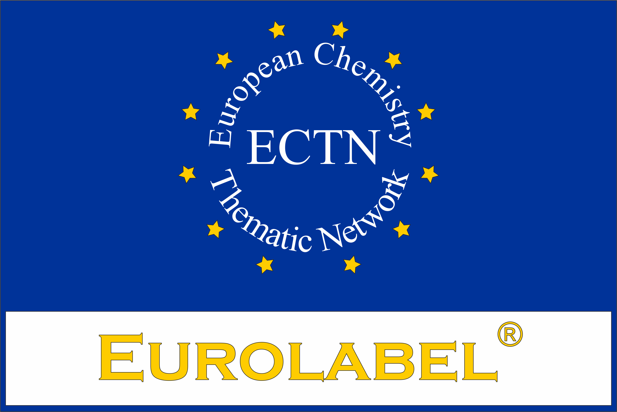
Table to be filled in on each programme that is submitted to Eurolabel® application. Data contained in the table will be used by ECTN and published on http://ectn.eu/mobility/. By submitting the data the responsible authorities of the respective university agree with data basing and publication.

Institution (& ERASMUS Code) | English name of the institution | ERASMUS Code
 | Name of the institution in the original language
Faculty/Department | Name of the faculty or department
Qualification awarded (& ERASMUS Subject Area Code) | Title of the qualification awarded | ERASMUS Subject Area Code
Level of qualification (Bologna & EQF) | Level of Qualification (Bologna) | Number of EQF  (ex: 6 for EQF6)
Name of qualification (programme) | In English
 | In Original language
Person in charge of this programme | First name, last name, position, postal address, phone, e-mail address
Specific admission requirements | Specific admission requirements (Entry qualifications)
Language of instruction | Main language
Website of the programme | Address of the institution Web site
Short description of the programme (500 characters) | Key-words for scientific content
Mode of study | Full time or part time
Duration | Number of semesters in the program (ex: 4)
Number of ECTS credits | Number of ECTS in the whole program
Academic year in which this degree was, or will be, introduced (valid for 5 years) | e.g. 2012 (5 entry years written as followed 2012-2016)
Beginning of the program (month):
Academic calendar:
Application deadline (if any):
Hyperlink to course guide:  ECTS Catalogue | Link where the ECTS catalogue is available
Hyperlink to further documents | Link to further documents
Eurolabel® awarded? | Date of award by (Agency or ECTN), Certificate N° of the Eurolabel® awarded (Eurobachelor® / Euromaster® / Doctorate Eurolabel®)
Person to be contacted for information about this programme | First name, last name, position, postal address, e-mail address
Last modification of this programme | Year of last modification

